Verbal-Visual Essay
FIRST PAGE:
You will be designing a collage of images that relate to the novel Fatty Legs. In other words, you will be creating a visual representation of the novel.
Visual Component:
You can include either pictures, graphics, drawings, cut-outs from magazines, etc. No matter how you design it, the images must relate to the story, characters, and (most importantly) the themes of the novel.
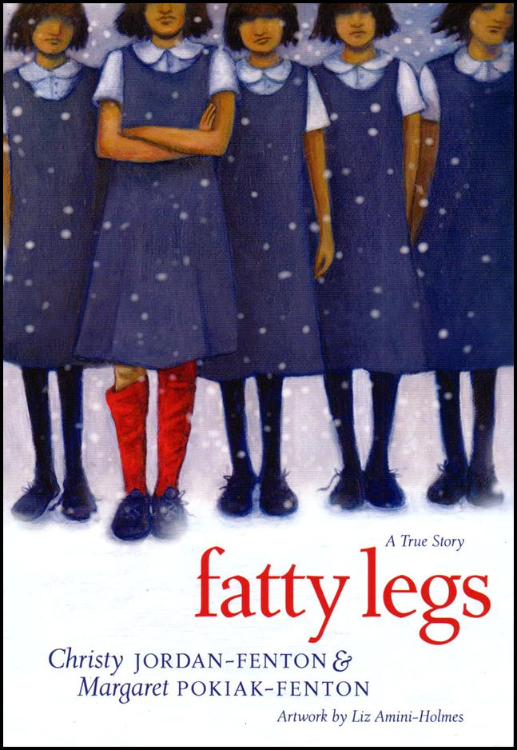
Verbal Component:
You must provide 5 quotations that you think are important to the novel (with page references).
You must write 5 statements that you think of on your own that relates to the novel.
SECOND PAGE:
You will list the 5 quotations and the 5 statements that you wrote in your collage.
You will then write an expository paragraph (minimum 200 words) explaining the symbols and images used, and how the different parts of your collage relates to the novel Fatty Legs.
Why are you doing this assignment?
For most of you, this is the first time taking an English course. I know this task looks like an art assignment, but you will not be marked on your artistic ability. Rather, this assignment is geared to develop your analytical skills and your ability to explain the reasons behind your decisions; both these skills are important in life and job situations. You will also solidify your understanding of the literary devices that you have learned during the course of reading Fatty Legs (e.g., metaphors, similes, symbols, personification, etc.).

RUBRIC FOR VERBAL-VISUAL ESSAY

STUDENT(S): ________________________________________ DATE: _________________

Categories | 50-59%  Level 1 | 60-69%  Level 2 | 70-79%  Level 3 | 80-100%  Level 4
Knowledge/  Understanding  You have a clear understanding of the novel through the images, quotations and statements that you use. This understanding is evident in the expository paragraph as well. | Demonstrates limited understanding of the content.  (1 mark) | Demonstrates some understanding of the content.  (2 marks) | Demonstrates a considerable understanding of content.  (3 marks) | Demonstrates thorough understanding of content.  (4 marks)
Thinking/  /Problem Solving  You are able to explain the symbolism of the different parts of your design and how each part relates to the theme and plot of the novel. | Uses critical/creative thinking processes with limited effectiveness.  (5 marks) | Uses critical/creative thinking processes with some effectiveness.  (6 marks) | Uses critical/creative thinking processes with a considerable amount of effectiveness.  (7 marks) | Uses critical/creative thinking processes with a high degree of effectiveness.  (8-10 marks)
Communication  You follow the instruction and follow the example v-v essay effectively.  Your grammar spelling and punctuation conventions are used effectively. | Uses writing convention and vocabulary (e.g., literary devices), and expresses and organizes the information with limited effectiveness.  (5 marks) | Uses writing convention and vocabulary (e.g., literary devices), and expresses and organizes the information with some effectiveness.  (6 marks) | Uses writing convention and vocabulary(e.g., literary devices), and expresses and organizes the information with considerable effectiveness.  (7 marks) | Uses writing convention and vocabulary(e.g., literary devices), and expresses and organizes the information with a high degree of effectiveness.  (8-10 marks)
Application  You clearly show the link between the novel and your collage; you represent the theme of the novel effectively. You are transferring your knowledge of the book to a new context. | Transfers knowledge and skills to new contexts with limited effectiveness.  (1 mark) | Transfers knowledge and skills to new contexts with some effectiveness.  (2 marks) | Transfers knowledge and skills to new contexts with considerable effectiveness.  (3 marks) | Transfers knowledge and skills to new contexts with a high degree of effectiveness.  (4 marks)

